YouTube Guidelines
2

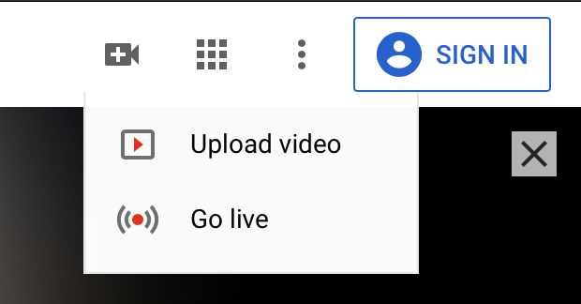
Upload your video to YouTube.
First, record a video of yourself presenting your poster. Follow the guidelines from your organization for time length and format. Then, upload the video to YouTube.com by following these steps:
- Log in to your YouTube account. (Create an account if you do not have one.)
2
- Click the video icon at the top right, then click “Upload video.”
- Click ‘select files to upload’ to find the video file saved on your computer. Or, you can drag and drop it into the window.
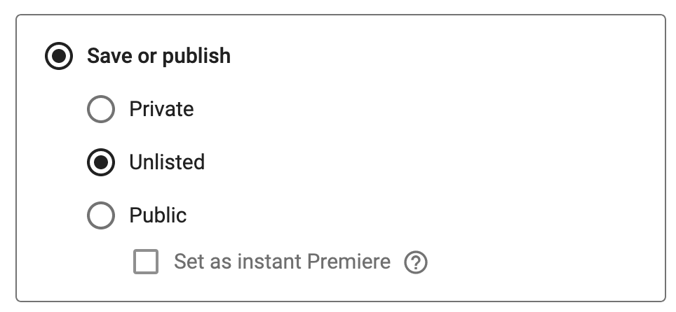
- Make the title of your video the same as your poster. We recommend adding a short description that includes your name, but other features like thumbnails, tags, end screens, etc., are not required.
5
5
- Visibility: Please select either “Unlisted” or “Public.” If you select “Private,” judges will not be able to view and evaluate your video.
- Click “Save” to complete your upload. Make sure your video uploads completely.

You can find your link by logging in to your YouTube account and clicking “Videos” on the left panel. Then, click on your video to view the video details. The link will be visible on the right underneath a thumbnail of your video.

Complete the Event Registration form by October 23 at Midnight

Submit your Presentation Materials (PowerPoint, YouTube video link, and Zoom link) by November 1 at Midnight

Questions?
Email us at help@rocketjudge.com, or contact us through our website, www.RocketJudge.com.

