Engineering Staff Advisory Council Agenda
Friday, April 5, 2019 8:30 a.m.
SHL Conference Room

- Call to order 8:30 AM
Attendees: Jacob Heiden, Sarah Livesay, Rachel Marek, Dawn Marshall, Jennifer Portwood, Blake Rupe, Chris Schwarz, Brian Snider, Kristina Venzke, Jan Waterhouse, April Tippett
UISC visitors: Gregory Hopson, Yelena Perkhounkova, Katie Millard

ESAC Update to UISC:
- ESAC bylaws and website were updated
- Working with College of Engineering and Facilities Management on building cleanliness issues reported by staff
  - One barrier is that custodial shifts are set at the UI and those shift times coincide with perceived high traffic times in the Seamans Center
- Desire for staff to be involved in discussions of Public Private Partnership
- Discussion of professional development opportunities for staff at UI
- College of Engineering staff can and do serve on committees even though they are not members of ESAC
- Executive Committee meetings with Dean each semester to bring topics to their attention as well as receive updates
- ESAC organizes Q&A sessions where staff may ask Dean and college administration questions
- ESAC has been invited by Sue Curry to nominate a staff member to serve on the search committee for the new College of Engineering dean
- Approval of minutes from previous meeting – approved unanimously
- Announcements
  - New ESAC members Sarah Livesay and Jennifer Portwood were welcomed.
- Impromptu new business items for this agenda - none
- Liaison Reports
  - UI Staff Council (no report)
  - HR Director Jan Waterhouse
    - Nominations for all staff awards are due Wednesday, April 24, 2019. The awards ceremony is Thursday, April 18, 2019.
    - College of Engineering is hosting 2 speakers on April 17 on the topic of Diversity, Equity and Inclusion
    - Director of Academic Resources and Support; 2 interviews are done, 1 to go
    - H.S. Udaykumar will serve as Interim Associate Dean for Graduate Programs & Research
  - Finance Director April Tippett
    - Number of first year incoming students looks to be higher than last year. May 1st is the deadline for potential students to pay their deposit
    - New program proposed is pending Board of Regents approval is the Masters of Science in Engineering and Information Technology. If approved, the new program would begin Fall 2019 and is located in the Quad Cities targeting working professionals.
    - New graduate training grant in Biomedical Engineering scheduled to begin August 2019.
    - FY19 revised revenue projections are due to central administration on April 17
    - Billable hours request for ESAC for second half of FY19 was approved by Dean Scranton
  - Diversity, Equity, and Inclusion Council
    - Book “A Guide to Gender: The Social Justice Advocate’s Handbook” is a suggested resource
    - RFP is open until March 8
    - See update from Josh Atcher in Appendix A
- Budget Update – Treasurer Jacob Heiden
  - February expenses were $507.73
  - Projected balance of $299.78 currently
  - Staff hours are now up to date
  - Two more ladles and stands were ordered for future Chili Cook Off events so they are on-hand and can be presented at the event
- Committee reports
  - Executive
    - Owl device for remote meetings does not work as well during meetings as it did when tested potentially due to the number of people in room during meeting
    - Public Private Partnership RFQ was not released on April 1 as expected, language is still being discussed, cost/profit opportunity might not be the same as at other institutions, no new timeline has been set; a memo was drafted from the College of Engineering outlining educational opportunities, environment and sustainability activities that could be affected (Appendix B)
    - Nominations for staff to serve on dean search committee are needed soon, nominations to Sue Curry are due April 11
  - Elections
    - Ordered staff appreciation items
    - A day to distribute items needs to be identified
    - Call for nominations to ESAC will go out in May with elections in the second half of May
  - Staff Awards
    - 6 award nominations were received; 4 for the Mary Sheedy, 1 for Community & Professional Service, 1 for Research
  - Social Events
    - Grill Out planned for July, planned for lunch time, vegetarian/vegan protein options will be provided, still looking for a grill
  - Get to Know the College
    - Happy Hour on May 16 at Mellow Mushroom in Coralville 4:30-6:30 PM, families welcome
    - Iowa Advanced Technology Laboratories a possibility for an open house this summer
  - Publicity, incl. Welcome/Goodbye
    - ESAC will send an email encouraging staff to attend the Listening Posts hosted by the college Diversity, Equity and Inclusion council
    - There 3 departures coming up
    - When we print new welcome cards we will add more information about ESAC
  - Bylaws/Policies & Procedures
    - Move to vote on proposed bylaw revisions – Rachel Marek, second – Jacob Heiden; approved unanimously
    - UISC suggested ESAC include in our bylaws that the organization representatives on UISC attend ESAC meetings, ESAC agreed to discuss at a future meeting
  - Community Service
    - Last of the Spread the Love event donations have been collected
  - Sustainability
    - Still working to get signage in Seamans Center up to guidelines, the correct size of stickers for containers in the annex have been ordered
    - Mayor’s Youth Empowerment Program – 293 items of trash have been removed from recycle bins across 8 visits; one participant received a job offer based on their participation in this program and work at the College of Engineering
    - Composting for students in the college in the Hanson Center with a staff monitor is being discussed
    - Meeting tomorrow with EcoCare/CompostNinja to discuss future plans
    - ESAC encouraged visitors to take composting across the UI back to the UISC as a topic
  - Wellness
    - Wellness grant funds for 2 desk cycles for Seamans Center were received, working on the details such as location, liability waiver, etc., expect cycles to be available next month; check out will be for 1 hour
    - Possible future events are yoga and a games lunch session

- Old Business
  - Budget for 2019 – 2020
    - Amounts from committees were discussed, Jacob will send a draft
  - Q&A with the Dean update
  - Public-Private Partnership update
  - Strategic Plan update
  - New Dean search
  - Facilities Management update

- New Business
Action Items:
Rachel - send Jan Waterhouse a copy of the liability waiver for the desk cycles
Jacob – send draft FY20 ESAC budget request to members
All Committee Chairs – send summary of committee activities to Blake for inclusion in the annual report to the dean

Next meeting
May 3, 2019 8:30 a.m.
4602 Seamans Center

Appendix A – Diversity, Equity and Inclusion council update to ESAC
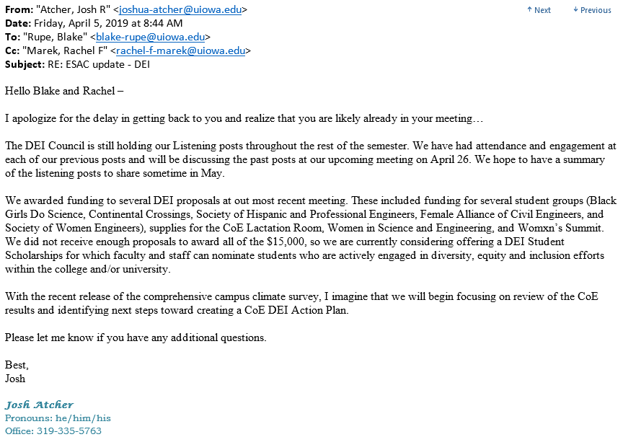

Appendix B – Memorandum on Public Private Partnership
